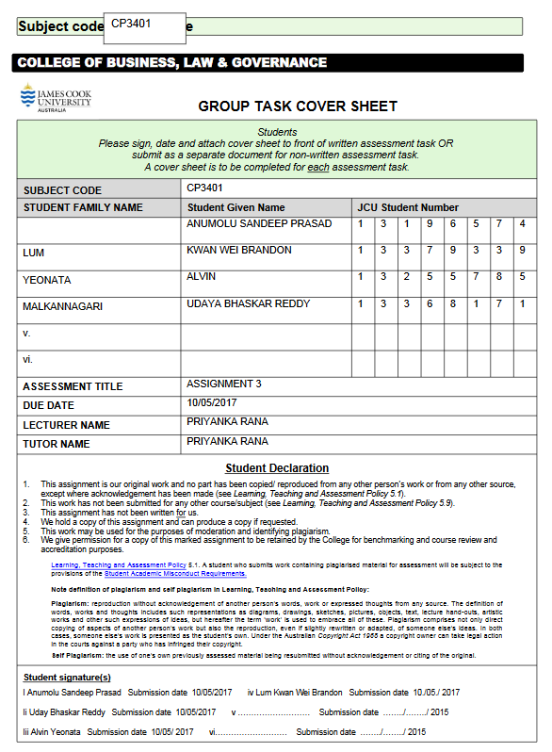

**Executive Summary**

The use of the internet for online shopping has grown dramatically over the past decade. The ease of buying goods by sitting at the comfort of their homes has provided the consumers a myriad of choices while making a purchase. When we look at the current scenario, almost three out of every five companies are using e-commerce as a means to offer their goods and services. Our website is designed in a way to cater to these existing demands of the consumer.

Our mission:

We are an online shopping website that offers a wide variety of gift products to our consumers. We acquire licensed products by forming strategic partnerships with several companies and sell them through our website. Our business model is a B2C model that deals directly with our consumers.

The company and management:

Our company is stationed in Singapore, and we operate our functions through the use of a website. We are not a physical store and all our purchases are made through this website.

Products Sold:

We offer the customers an option to customize their own goods. In addition to that, we offer them a wide array of different themed products to choose from, including:

* Entertainment Crates, which offer exclusive collectible from movies to TV shows.
* Anime Crates, which offer a wide variety of anime products from figurines to t-shirts to signed copy of original anime series.
* Gaming Crates, which offer exclusive collection of games specifically catering to the younger age groups.
* Office Crates, which attract the niche market class by offering goods ranging from stationery products to designer suits.
* Art Crates, which offer a myriad of collectibles that embraces the soul of the connoisseur of art.

Targeted Markets:

Our main target markets include the South East Asian Regions. We have designed our products specifically to cater to the interests of these ethnic groups. Our Gaming and Anime products have a thriving business in these areas and we believe, we can make a strong impact by offering a variety of choices to our consumer in a cost-effective manner.

**Value Proposition**

The needs of customers our service will fulfil

The main value of our service is to break the monotony of a consumer choice. The key elements of our value proposition that entices our customers include:

* Cost Effective - meets any budget
* Always delivers the “Wow” experience
* Makes the life easier through online purchases
* Provides a variety of superior products and packaging

At the core of our business is our niche. This is based on the types of goods and services we offer. Our products own a special characteristic to entice the customer into buying them. For example, we define our customers’ interests by providing artisan goods to people who prefer niched products over normal products. This adds more value to our services.

While niche defines the ethos of our business, our value proposition defines the value of the product in our gift box. And this is not solely based on the monetary value of the product. The consumer while making a purchase will not be aware of the type of gift that they will receive. This adds an element of excitement to their purchase. And once they receive the goods, they will be pleasantly surprised at what they get. Rather than a monotonous way of physically going to a store and buying a product, we believe our unique model will make sure in keeping our customer interest alive throughout the process of purchase.

Why should the customers buy into / use our services?

There are many prospective features that our customers can look at before buying our products. Our business is based on a monthly subscription model. This allows for a very cost-effective implementation of our services to the customers. We offer products at very reasonable budget prices. Furthermore, our inventory provides a wide variety of goods to choose from. This allows us to cater to all age groups in the market. The consumer will have a large inventory to pick their choice of interest.

In addition to this, we provide customized goods as a service. This will allow the consumers more freedom in choosing their products. We also deliver the products to the consumer’s door steps with very less transportation charges. We also promise a faster delivery of goods to our customers, and all their gifts will be replaced in case of any damage during transit. Our website is specifically designed in a way that it provides easy navigation to the consumer while making purchases.

We have plans to incorporate an element of charity once our revenue stream stabilizes. On every purchase the consumer makes, we intend to give a percent of it to social organizations for charity purposes. This will be another incentive for the consumer to buy a product at our store.

**Market Opportunity**

What marketspace/customer segment does our business intend to serve?

Our business intends to target the niche market of online subscription box services in Asia, starting with Singapore. Existing services often focus on a particular area of the market for their products, examples being IPSY (<https://www.ipsy.com/>) that ships beauty products, and Lootcrate (<https://www.lootcrate.com/>) that ships collectibles relating to games and comics. Such focus has allowed these businesses to grow and attract a large subscriber base in their respective genres, especially in western countries.

We, however, plan to target all these markets in Singapore, as a start, by offering different themes each month, accompanied by several boxes per month that provide the various collectibles or utility-based items to satisfy a larger audience. Our reasoning behind casting such a wide net is simple. We want the customer to be able to truly receive a gift that contains the element of surprise, as is our selling point. While we believe that majority of our potential subscriber base would enjoy our monthly products, a small portion of them might be completely uninterested in the particular month’s items.

Having multiple options to choose from allows them to have the option of forwarding the box to an acquaintance of theirs which they believe would enjoy it, thus allowing them to stay subscribed to our service without feeling the need to opt in or out according to what is offered monthly. Our business will be considered a one-stop shop for a large range of available products, provided by a multitude of emerging startups to established businesses.

As our service grows, we will have to adapt accordingly to the feedback of our customers, as well as monitoring trends to determine the viability and life of our current and future products. This would allow us to proactively approach the companies to obtain partnerships and exclusive selling rights ahead of our competitors, allowing us to provide first to market products that increase our uniqueness and service recognition across the region.

What is the market size of the selected marketspace/customer segment?

According to a Google Trend search (Appendix A), there is a constant growth in consumer interest with regards to subscription boxes. The interest by region shows that countries such as the US, UK and Canada are leading, at 100%, 80%, and 69% of all queries,  followed loosely by Singapore at 60%. The closest asian country to follow is the Philippines at 17%. This reflects well on our initial goals with regards to the market opportunity, in the sense that there is an untapped market in Asia that we can cater our business model towards, after successful implementation and growth of our business in Singapore.

We can refer to how well these subscription services did in other countries, such as the US, to obtain a rough idea on how our growth would be, and how to build our subscriber base. According to a report published on Internet Retailer, visits to these subscription service sites have grown from 722,000 in January 2013 to 21.4 million in January 2016.

Another reason why we choose to start this business in Singapore is because majority of its citizens boast a strong disposable income (as assumed based on information about the gross monthly income from Appendix B) which allows them to buy into our service if we are deemed affordable.

**Cost structure and Revenue model**

How our e-commerce earns money

Our company’s primary e-commerce business plan involves the sales of our ‘crates’ to be delivered at the customer’s doorstep at a specified date every month. We will also be featuring a subscription-based service to avail these crates for a longer period of time at a discounted rate. This provides predictable early cash flow to the company to support our back-end logistics infrastructure. (Josh L., 2017).

The revenue model(s)

Upon establishment, our company’s preliminary revenue model will provide B2C (Business-To-Consumer) services to our target market via e-commerce sales of our crates. Further down the line after the establishment of significant strategic partnerships and developing brand identity, we will proceed to also leverage our position of being able to generate revenue through licenses, by offering smaller businesses and independent creators an opportunity to place their products in our crates for a price, thereby establishing a B2B (Business-To-Business) revenue model as well.

The estimated dollar amount required to fund the establishment

The estimated dollar amount to fund the establishment of our business would be SGD 50,000. Please refer to Appendix C which displays the breakdown of the capital that will be invested in various segments of our company’s operations. Due to our business operations involving licensing and logistics, the lion’s share of the capital (SGD 22,500) will be used for acquiring storage space and inventory purchasing. The subsequent critical parts of our business are both, establishing licensing agreements and deploying a modern e-commerce platform which will both receive SGD 10,000 in funding. And finally, since our market strategy involves capturing the attention of an educated audience, we have assigned SGD 7,500 for our marketing campaign upon the launch of our business.

PENDING

**Market Strategy**

Plans to promote our service through online marketing activities

We plan to promote our service through a variety of advertising avenues. The primary approach would be the Search Engine Optimisation (SEO) of our website. This allows potential customers to discover us easier through sponsored links and keyword searching on search engines. To simplify it, proper SEO implementation directs all relevant traffic to our website, granting us better exposure in the online environment.

We will also branch out and contact local figures/celebrities, providing them with free samples of our product boxes in exchange for publicity. These popular figures can unbox these items in a recorded advertisement video, allowing them to showcase what our service has to offer to their various fanbases.

Plans to attract new customers, grow the market share, and retain customers

Our primary method of retaining customers would be to consistently query them on their satisfaction of the month’s products, allowing them to provide feedback as to whether they like the products found within, the overall theme of the box, as well as any suggestions towards possible products to be included. We will be using these feedback with heavy consideration when approaching potential partners and deals.

We will also be constantly reviewing our business and advertising strategy. We will have to stay on top of the trends as they change, and adapt to it by quickly recognising businesses and partnerships that will allow us to obtain exclusive rights to the first-to-market product. By staying at the top of our game, we will be able to increase our customers’ trust in our company’s ability to provide them with dynamic and interesting products every month, increasing our service’s brand awareness and possibly gain more market share in the form of more customers and subscriptions.

Metrics used to monitor the effectiveness of the marketing activities

One obvious metric to monitor is the traffic of our business’s website. Specifically, tracking the number of unique visitors, how long they stay on the site, and which pages they view. Other metrics include:

1. Conversion rate, where the customer chooses to subscribe to our service after visiting our website.
2. Bounce rate, the percentage of visitors that leave our website after only viewing the homepage, can be used to determine if the way we portray our service is efficient and/or satisfactory through the website design.
3. Customer Retention Rate, where we can calculate the number of customers that stay subscribed for a longer period of time, and gather feedback as to why they choose to continue or end the subscription with us.

**Human Resources**

The types of organization structures / employees necessary if the business expands very rapidly

The organisation structure as a startup company was planned so that there are only a handful of employees. If there were to be an expansion in the business, further employment will be conducted.

In the organizational chart (Appendix D), there will be a clearer structure of the organisation. There will be positions that will need to be filled; Human resources, Finance and Technical. Each of the positions will consist a team where they will fulfill their roles.

* HR Team
  + - Building relationships with other companies
    - Advertising company name(Branding)
* Finance Team
  + - Product pricing
    - Price negotiation with other companies
* Technical Team
  + - Website maintenance and updates
    - Storage & Inventory management

What kind of backgrounds/knowledge the company’s leaders or key business partners should have

The company CEO must be in a position to lead the product procuring team and maintain a healthy relationship with the strategic partners and investors. He must be aware of the long-term investments and the profit/loss scale that will be crucial in drawing in more investors for the future. These strategic partnerships form the backbone of any commercial enterprise to offer better quality services to the consumer. The key partners must be updated with all the relevant information regularly which helps in forging a better corporate alliance.

The company managers must also have an in-depth understanding of the changing market trends. This will allow the company to use its resources on priorities as per the current trends in the market and avoid wastage. This will affect in minimizing the overall cost structure.

Another key element in defining the success of the business is the inventory management. As the business needs a constant influx of changing inventory over time, the company technical team must be able to provide the goods and services required without any delays. This also includes the transportation and delivery services.

The website will be the face of the company and it needs to be maintained at all times. the technical team must be in a position to answer any customer calls and resolve their issues on time.

**Prototype Storyboard**

Screenshots and description of the mock-up website or mobile app to storyboard the key ideas of the proposed e-commerce.

* **Homepage**

The Homepage (Appendix E) shows the customer what this month’s crates will be themed on. There will be short descriptions about the company and what the crates will be consist of.

* **Pick a Crate**

The “Pick a Crate” page (Appendix F) is where the visitor can see the range of products that we will be packaging. These products are based on a theme that changes every month.

* **History**

The History page (Appendix G) highlights our past crates. This page will be updated every month to show what the contents of the previous month’s crates are so that the future customers know what to expect.

* **Partners**

The Partners page (Appendix H) will feature the current partners that we are getting our licensed products from.

* **Forums**

The Forums page (Appendix I) hosts a forum where the online community can share their experiences. This page also allows us to get feedback from the community and recommendations on how to improve services.

* **My account**

The “My Account” page (Appendix J) will consist of personal details of the customer that will be stored in the company’s database. Should there be a need to change any of these details, the user can do so here.

* **Contact us**

The “Contact us” page (Appendix K) provides a form that allows viewers to give constructive feedback or to query us on certain issues not addressed in the FAQ page.

* **FAQ**

The FAQ page (Appendix L) is where the frequently asked questions are answered. This is for the customers who are uncertain of subscribing to the service and the answers will clarify their queries.

* **Checkout**

The Checkout page (Appendix M) will allow the customer to place an order and show the status of their order.

**Team Contribution of this Assignment**

|  |  |
| --- | --- |
| **Member Name** | **Contribution** |
| Anumolu Sandeep Prasad | Cost Structure and Revenue Model |
| Udaya Bhaskar Reddy Malkannagari | Executive Summary, Value Proposition, Human Resource (Secondary) |
| Lum Kwan Wei Brandon | Market Opportunity, Market Strategy, Report formatting |
| Alvin Yeonata | Human Resources (Primary), Prototype Storyboard |

**References**

1. Internet Retailer. 2016, March 22. Online Retailers think outside the subscription box. Retrieved from: <https://www.digitalcommerce360.com/2016/03/22/online-retailers-think-inside-subscription-box/>
2. DeMers, Jayson. 2014, August 15. 10 Online Marketing Metrics you need to be Measuring. Retrieved from: <https://www.forbes.com/sites/jaysondemers/2014/08/15/10-online-marketing-metrics-you-need-to-be-measuring/#4578d4ef76c1>
3. Lazar, Michael. 2016, September 8. Why Subscription Commerce is taking Center stage. Retrieved from: http://www.huffingtonpost.com/michael-lazar/why-subscription-commerce_b_11410776.html

**Appendix**

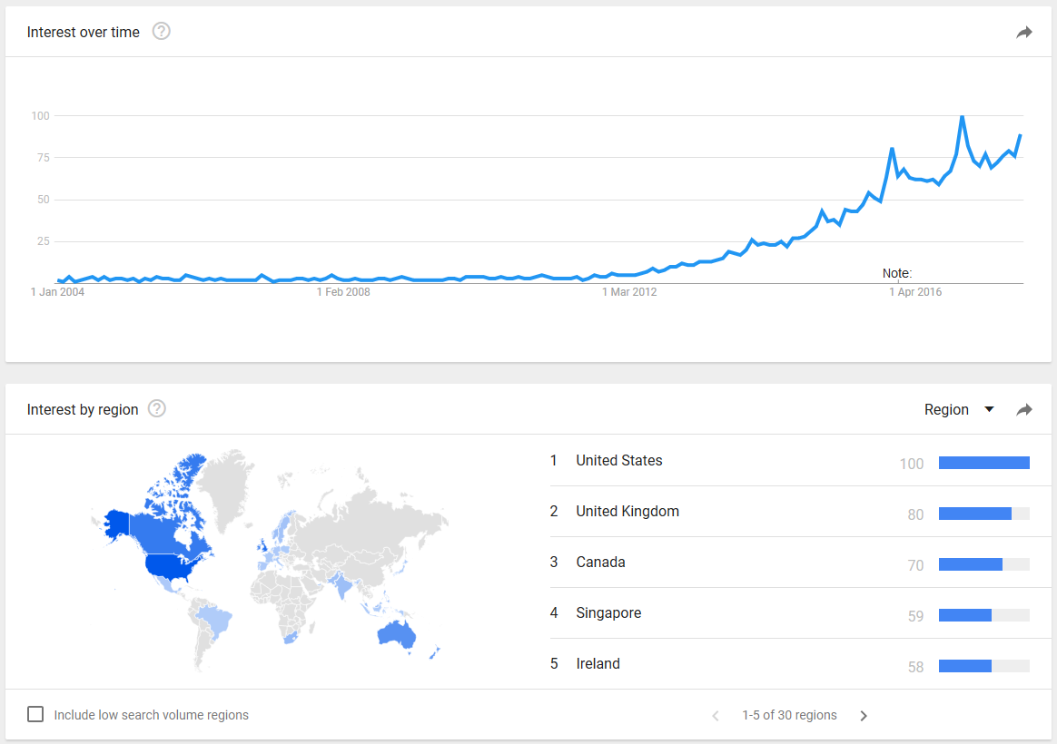

Appendix A. Google Trends search on keyword “Subscription Box”. Retrieved from: <https://trends.google.com/trends/explore?date=all&q=subscription%20box&hl=en-GB>

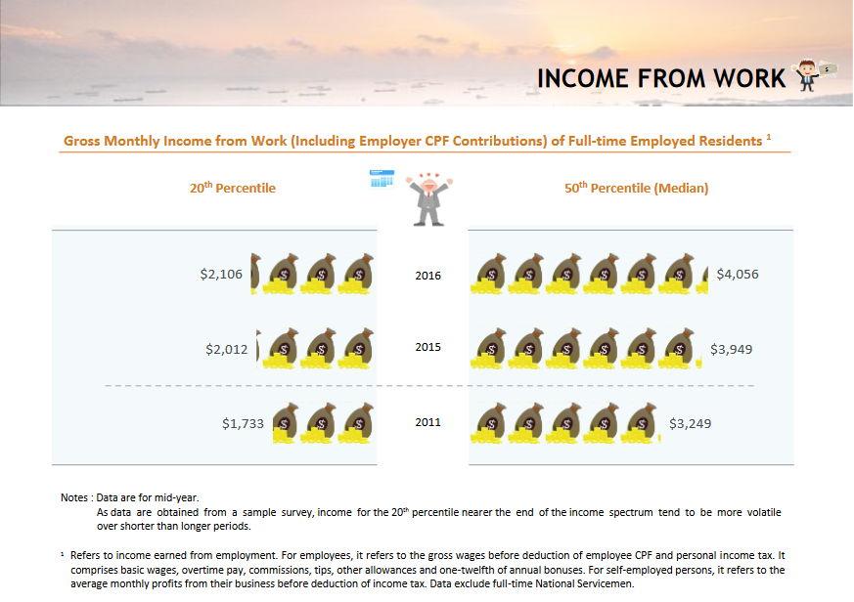

Appendix B. Singapore in Figures 2017, Section about Gross Monthly Income of Full-time Employed Residents. Retrieved from <https://www.singstat.gov.sg/docs/default-source/default-document-library/publications/publications_and_papers/reference/sif2017.pdf>

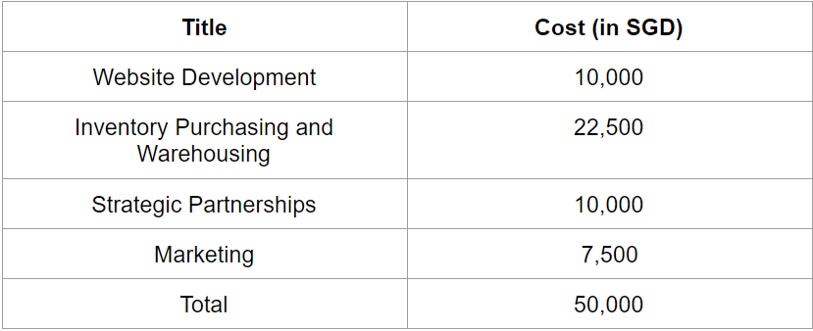

Appendix C. Estimated Dollar Amount to Establish Company

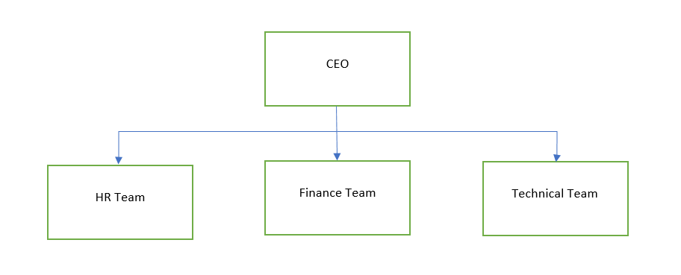

Appendix D: Organizational Chart of our Business model

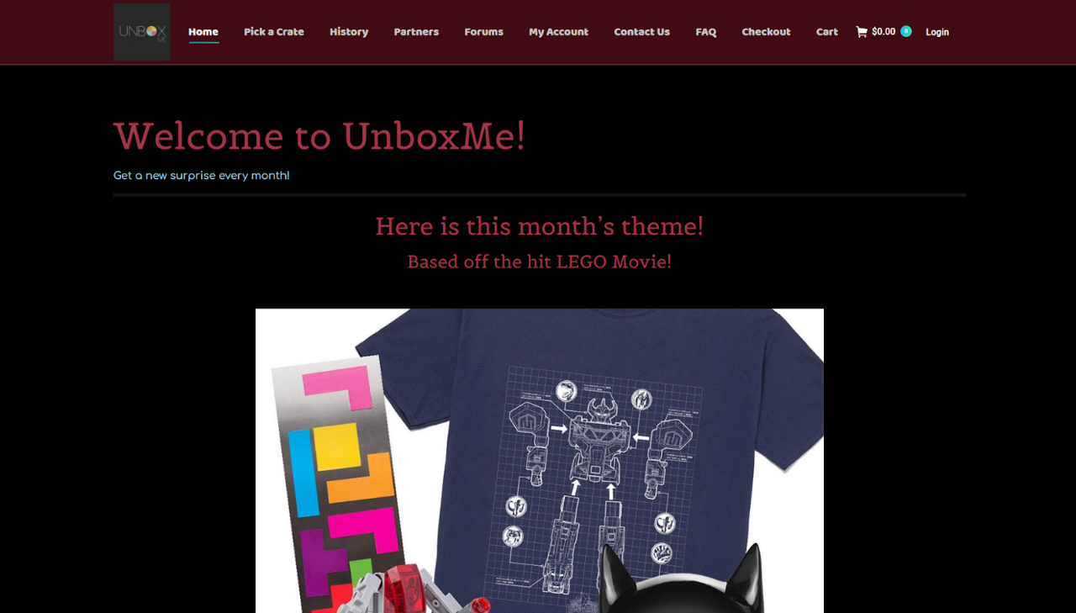

Appendix E: Homepage

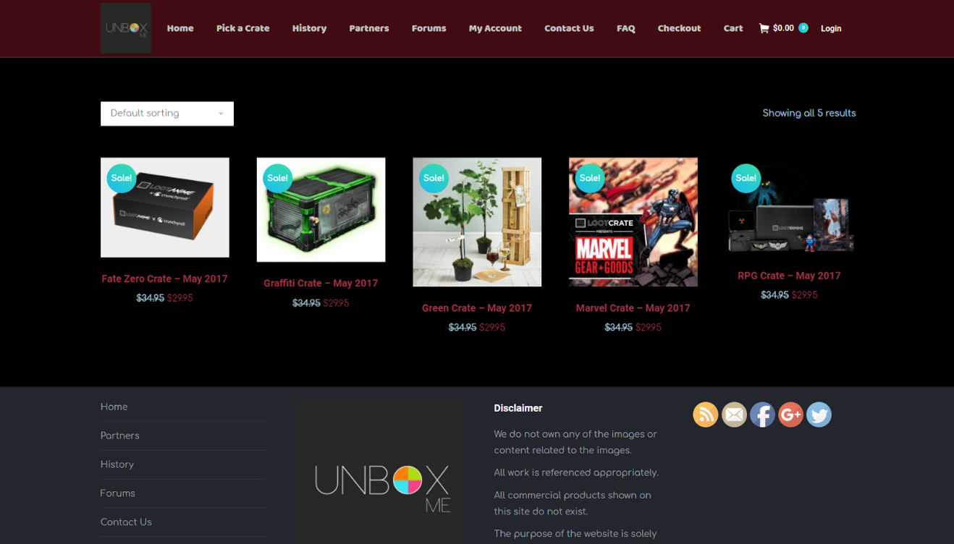

*Appendix F: Pick a Crate page*

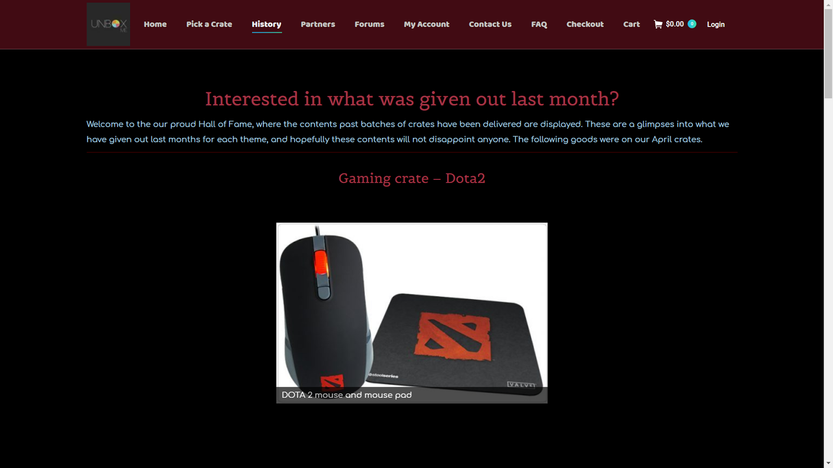

Appendix G: History page

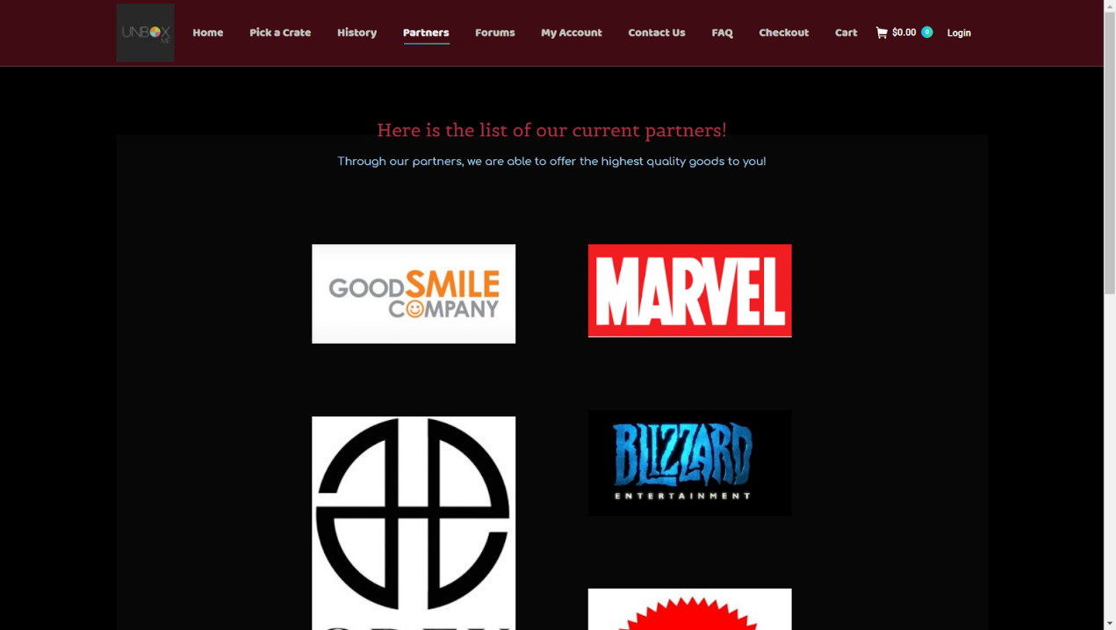

Appendix H: Partners page

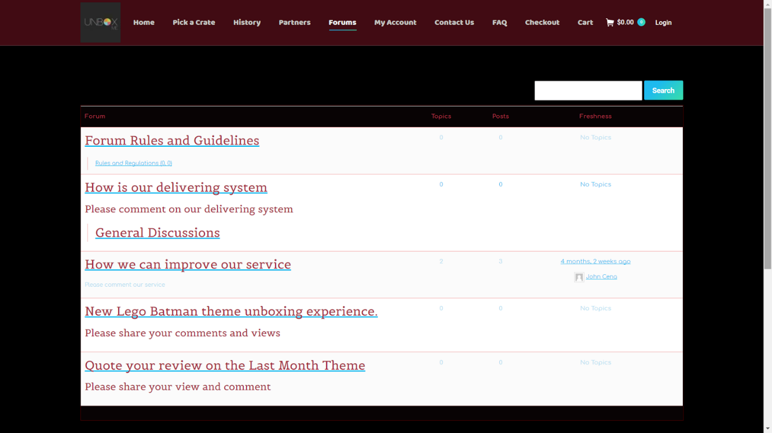

Appendix I: Forums page

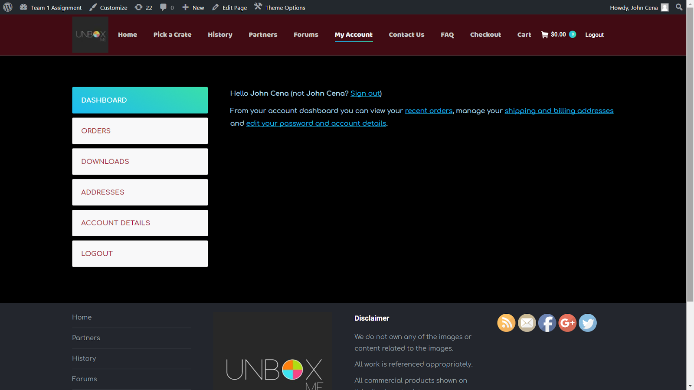

Appendix J: My account page

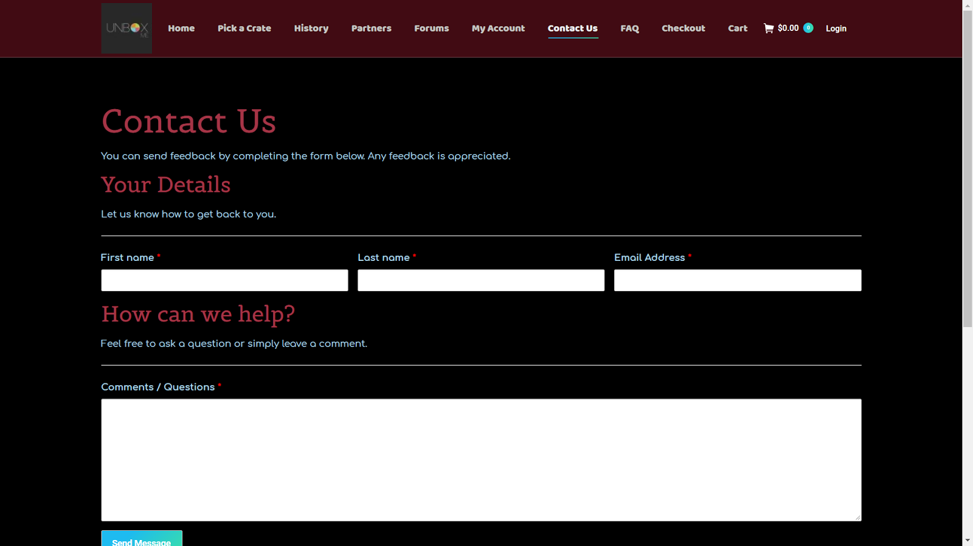

Appendix K: Contact us page

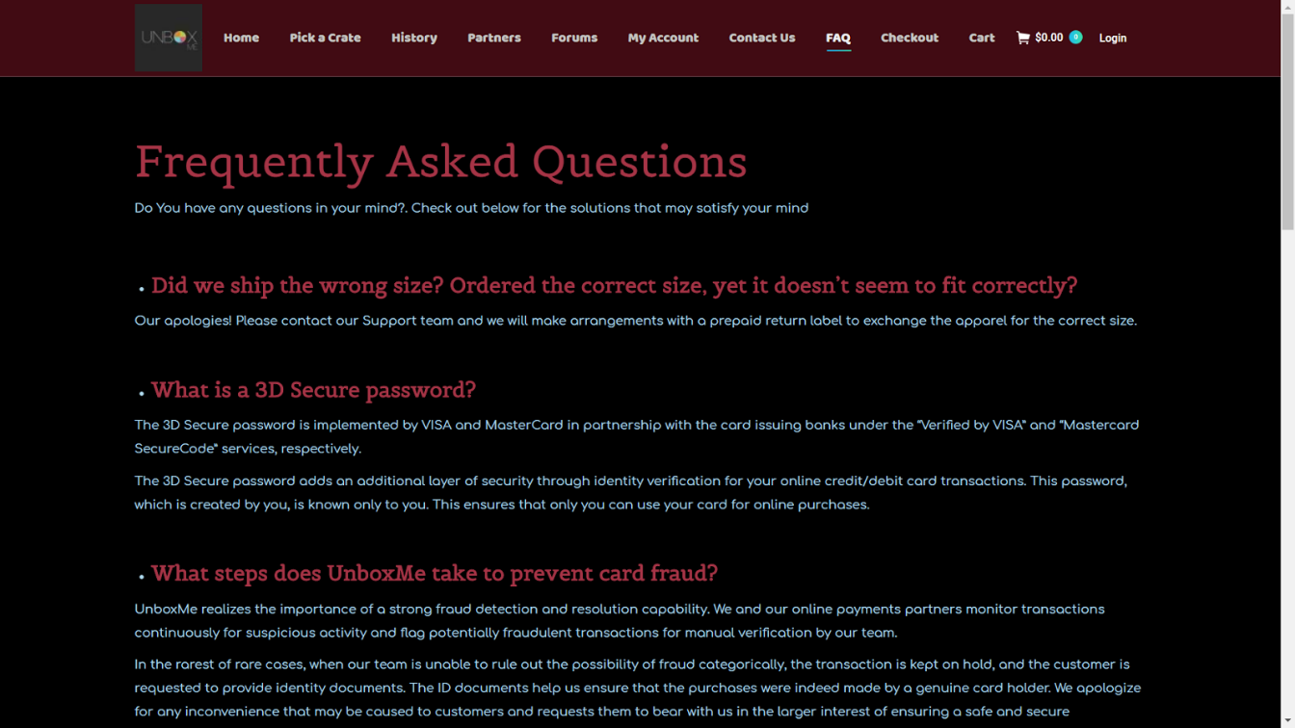

Appendix L: F.A.Q page

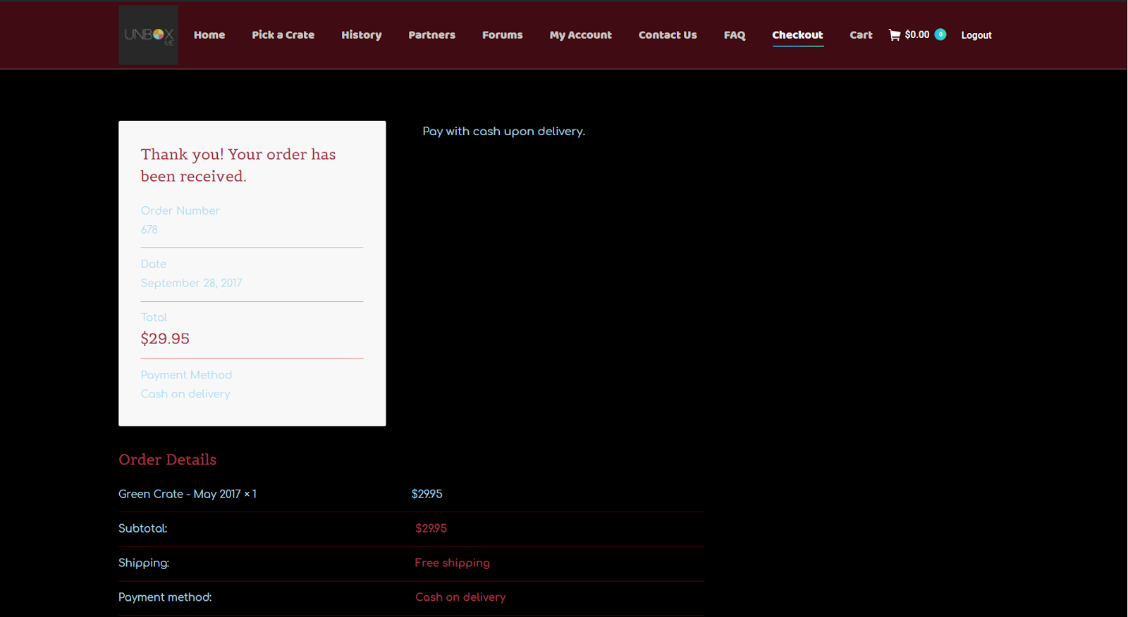

Appendix M: Checkout page.